Usability Testing Memo

This report summarizes the effectiveness of the usability test provided for three subjects. The usability test was accompanied with instructions for using a website to determine whether a cactus is suitable for growing in local conditions. The following report discusses the various positives and criticisms of the previously mentioned usability test in order to create a more finished product. Issues that people who have tested the instructions have been addressed and fixed in the updated version of the report.

Test Objectives

The objectives of this test were to record the issues and effectiveness of the instructions provided. This was completed through the method of timing the subject while they were completing the test and taking notes on their thought process throughout the ordeal. To accomplish the goal, the subject should be able to use the instructions to reach the end without any major issues in finishing. Another method of gaining important data was the use of questions after the testing session. These questions were designed to record the subject’s opinion on the test and find ways of improving the instructions. The final product should be clear, concise, and unambiguous for users with a variety of internet skill levels.

Results

**Areas of Strength**

The initial instructions provided were structured well for people to follow. Subjects were also able to accomplish their goals through following the steps. Some people who completed the instructions claimed they enjoyed the subject matter that was covered and that it made the test interesting.

**Areas for Improvement**

Most obviously, the area that needed the most improvement was the visual aids. Initial instructions were lacking in visual aids and this hampered the user’s experience immensely. In some cases, users were delayed after step 6 and couldn’t immediately locate the next item. Also, instructions were slightly unclear when discussing which zone information to locate.

**Questionnaire**

Close Ended Question Results

Would visual aids help the instructions?

Was your goal achieved?

Did the organization of the instructions match your expectations?

**Subject 1(Time- 4:40):** Yes, Yes, Yes

**Subject 2(Time- 4:20):** Yes, No, No

**Subject 3(Time- 3:20):** Yes, No, Yes

The results of these questions prove that the basic outline of the instructions are sufficient and useful.

Open Ended Question Results

Were the instructions clear enough in your opinion? Explain

Is there anything I left out?

What would you consider the best part?

**Subject 1(Time- 4:40):**

It was clear until the last three, the different name choices of the plant, locating zone information

**Subject 2(Time- 4:20):**

No it needed more information, pictures to go with the instructions, putting in your zip code

**Subject 3(Time- 3:20):**

No the instructions weren’t clear enough, visual aids to follow the steps with arrows, no it needed more concise instructions

These questions show the necessity of using visual aids to help the user of the instructions. All subjects stated that it would be useful for the overall experience.

Recommendations

The recommended course of action is to use the criticism provided to create a more user friendly experience. Visual aids were included to help users of the document to accomplish their goal and be aware of the next step required. Arrows will also be provided on the images to make sure people know which link to select. The organization of the instructions will remain largely intact but it is recommended to be specific on which cactus to find information for rather than let the user come up with a plant.

Appendixes

Original

Instructions for Determining Which Cactus You Can Grow Where

1. Decide which cactus you want to incorporate into your garden
2. Type <https://garden.org/nga/zipzone/> into the search bar and go to the website
3. On the website, locate the search bar for entering your zip code under the text that says “Find your zone using the map below or enter zip code”
4. Enter your zip code into the search bar and select “Go”. If your zip code is unknown, google search “What is my zip code?”
5. Record the zone information that is provided.
6. Under the zone information, select the link to “Check out our Plants Database” in order to compare your previously mentioned plant idea.
7. In the search bar labeled “Search for a plant”, type in your plant type and hit enter.
8. On the new page, scroll down until you come across the section of the table that mentions minimum and maximum zone
9. Compare your previously recorded zone with the minimum and maximum zone recommendations.
10. If there are no minimum and/or maximum zones, note the region recommended for growing.
11. Does your zone fall in between the recommended zone? If so you are able to plant and grow your cactus in the region you researched!

Revised

Instructions for Determining Which Cactus You Can Grow Where

1. Type <https://garden.org/nga/zipzone/> into the search bar and go to the website
2. Locate the search bar for entering your zip code under the text that says **Find your zone using the map below or enter zip code**
3. Enter your zip code into the search bar and select **Go**. If your zip code is unknown, google search **What is my zip code?**

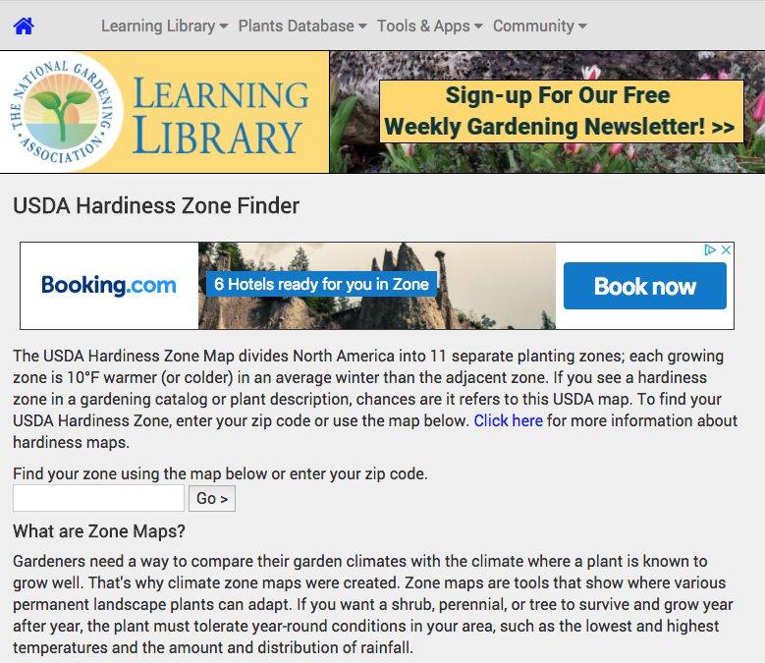

1. Record the zone information that is provided.



1. Select the link to **Check out our Plants Database** in order to compare your previously mentioned plant idea.
2. In the search bar labeled **Search for a plant**, type in **Brazilian Prickly Pear** and hit enter.

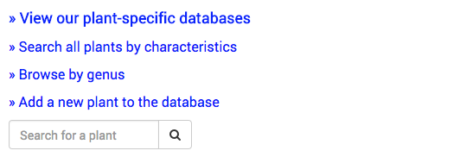

1. On the new page, scroll down until you come across the section of the table that mentions minimum cold hardiness and maximum zone

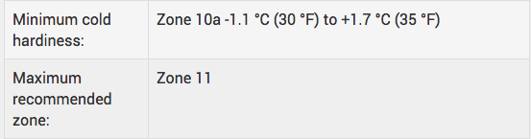

1. Compare your previously recorded zone with the minimum cold hardiness and maximum zone recommendations.
2. If there are no minimum and/or maximum zones, note the region recommended for growing.

../Desktop/Screen%20Shot%202018-04-03%20at%202.44.53%20PM.png

1. Does your zone fall in between the recommended zone? If so you are able to plant and grow your cactus in the region you researched!